Urban Crust Pizza Dashboard

Power BI Project Report
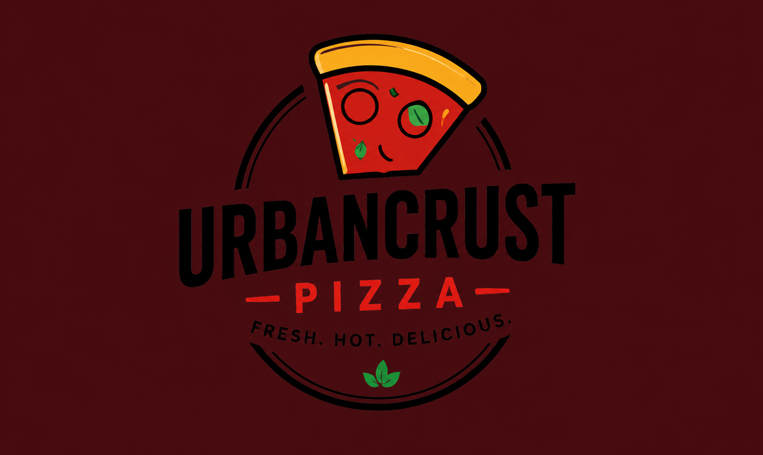
Prepared as a business intelligence project using Power BI.

Project Overview
The Urban Crust Pizza Sales Dashboard project was developed using Power BI to transform raw transactional data into meaningful business insights. The dashboard was designed to provide a complete overview of business performance using KPIs, product analysis, customer behavior analysis and interactive reporting. The project focused on helping decision-makers understand sales patterns, revenue contribution, profit trends and customer purchasing activity. Power BI visualizations were used to convert complex data into easy-to-understand insights.
The dashboard provides an organized reporting system that allows users to analyze performance at multiple levels. Different visuals and charts help identify trends and opportunities.

Project Objectives
1. Analyze sales performance.
2. Identify top and bottom products.
3. Compare sales and profit across categories.
4. Understand customer purchasing behavior.
5. Build KPI dashboards.
6. Create interactive reports using slicers.
The objective was to create a complete reporting solution that allows users to make better business decisions.

Data Source and Dataset Description
The dataset used in this project was adapted from a Kaggle pizza sales dataset. Multiple tables were used including Orders, Products and Customers. Orders contained transaction information such as sales and profits, Products contained pizza category details and Customers contained customer and regional information.
Orders table: Order_ID, Order_Date, Quantity_Sold, Total_Sales, Total_Profit.
Products table: Product_Name, Category.
Customers table: Customer_Name, Customer_ID, Region and State.

Data Cleaning and Transformation
Power Query was used for cleaning and transforming the dataset. Duplicate values were removed, missing values were identified and corrected, inconsistent formats were standardized and date columns were converted into a proper structure.
Data cleaning ensured better accuracy and improved reporting quality. Data quality checks were also performed before creating relationships and measures.

Relationships and Data Modeling
One-to-many relationships were created among Orders, Products and Customers. Product_ID and Customer_ID fields were used to connect the tables.
Proper data modeling helped filter propagation and enabled accurate calculations across visuals and reports.

DAX Measures and KPI Development
Several DAX measures were created such as Total Sales, Total Profit, Total Orders, Total Quantity Sold, Average Order Value and Customer Purchase Amount.
KPI cards were used to display these measures. KPI visuals help users quickly understand overall business performance without analyzing detailed tables.

Regional Analysis and Slicers
Regional analysis was used to understand customer purchase behavior across different locations. Geographic patterns help businesses understand where sales concentration exists.
Interactive slicers including Region, Category, Date and Year were used to make the dashboard dynamic. Slicers allow users to filter data and perform customized analysis.

KPI Dashboard
The following dashboard screenshot represents an important business visual used for analysis and decision-making. The visual helps users understand trends and identify patterns within the dataset.
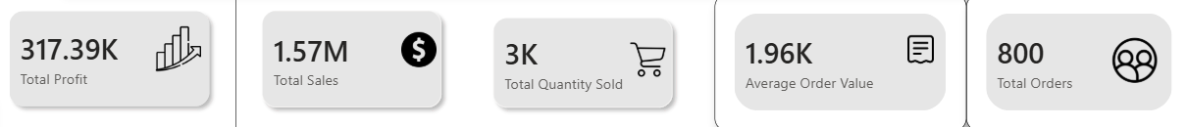

Sales Analysis
The following dashboard screenshot represents an important business visual used for analysis and decision-making. The visual helps users understand trends and identify patterns within the dataset.
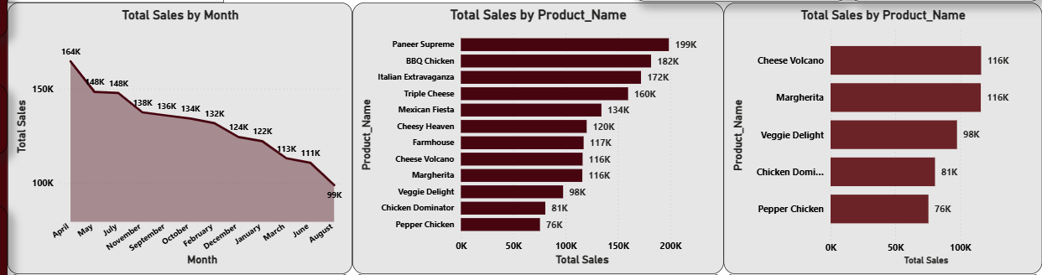

Category Analysis
The following dashboard screenshot represents an important business visual used for analysis and decision-making. The visual helps users understand trends and identify patterns within the dataset.
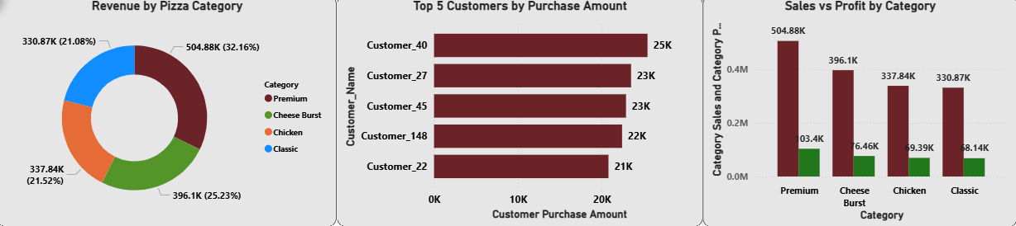

Product Analysis
The following dashboard screenshot represents an important business visual used for analysis and decision-making. The visual helps users understand trends and identify patterns within the dataset.
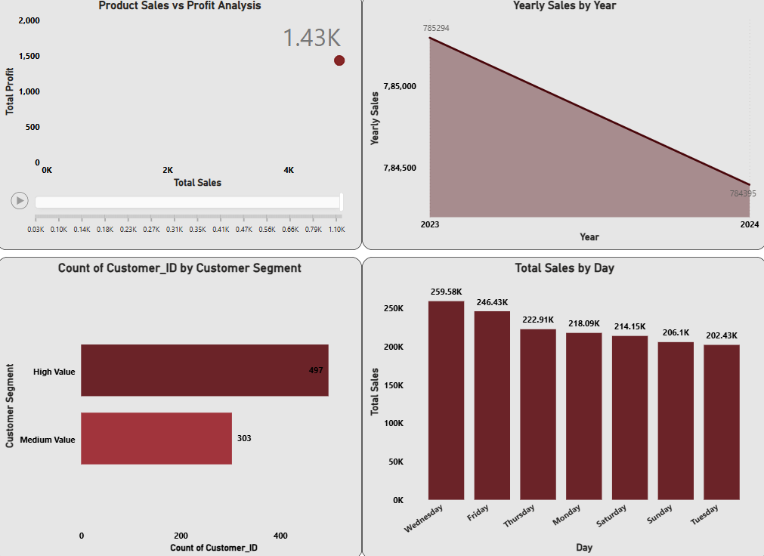

Insights and Conclusion
The dashboard identified high performing products and categories. Premium category generated higher revenue contribution while some products generated high sales but lower profit margins. Customer analysis and regional insights improved understanding of purchasing behavior.
The UrbanCrust Pizza Dashboard successfully transformed raw data into a complete business intelligence solution that supports reporting and business decision-making.

